Guide for Utilizing MTM’s Member Portal Mileage Reimbursement Form

1. Log in at <https://gmrform.memberportal.net>.
2. Enter the requested member information:
   1. Member’s Medicaid/Medicare ID number.
   2. Submitter’s email address.
   3. Submitter’s phone number.

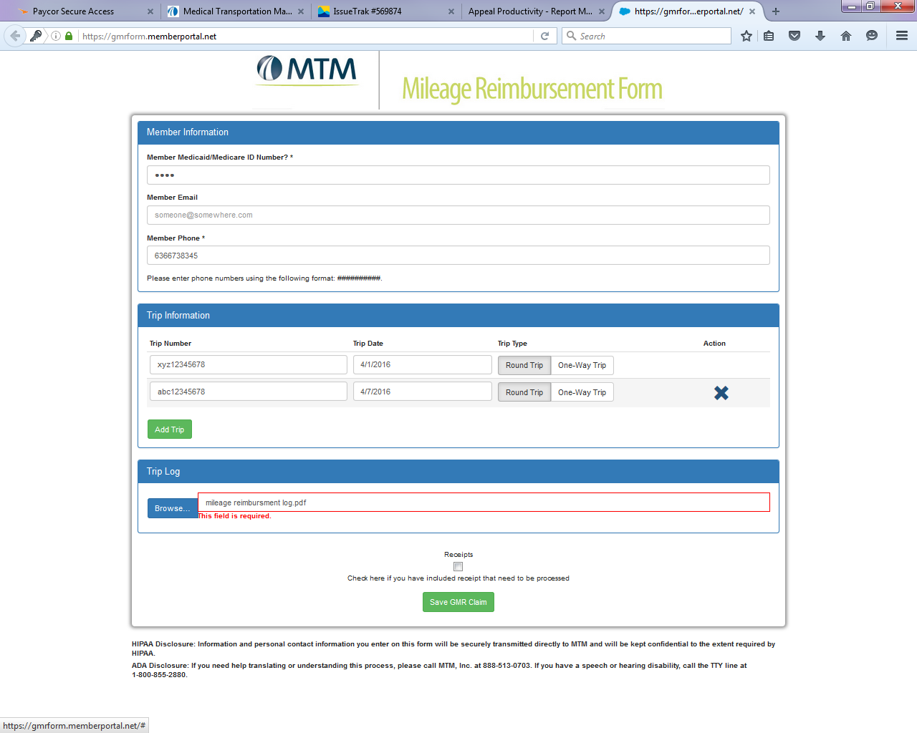

1. Enter the trip information, including trip number, trip date, and trip type.
   1. To claim more than one trip, select “Add Trip.”
   2. To remove a trip, press the blue “X” button.

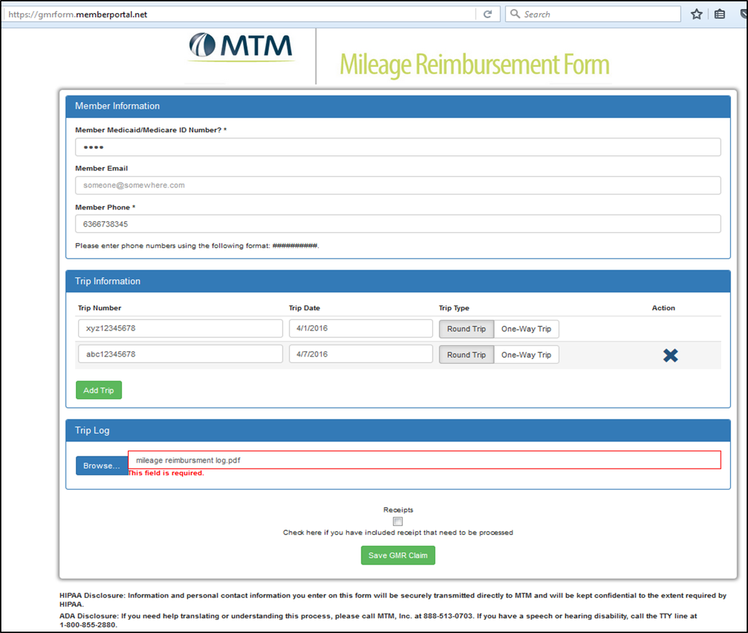

1. Upload trip log(s) by selecting “Browse.” A file upload box will pop up.

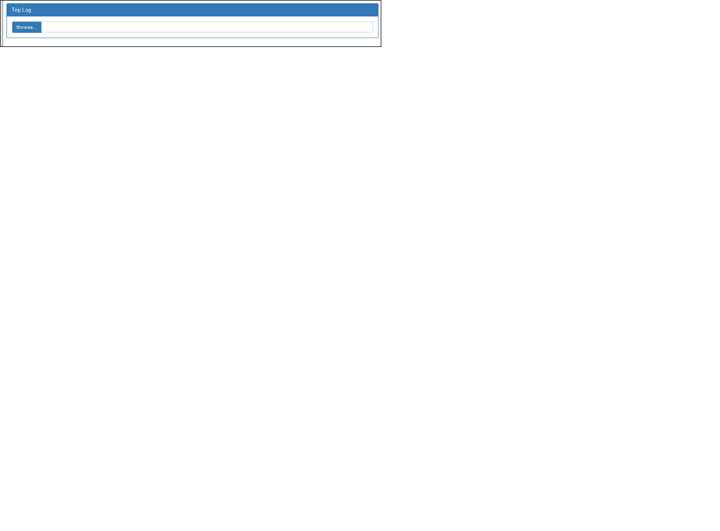

1. Using the file upload box, select the file to be uploaded and press “Open.” Only one file can be uploaded at a time, so multiple trip logs and receipts must be scanned into one file.

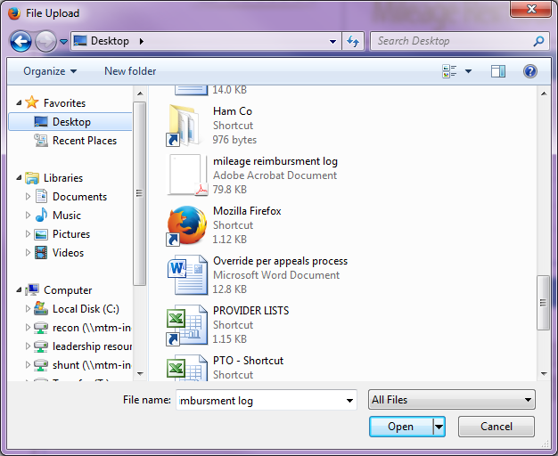

1. After the uploaded file appears in the “Browse” box, check the “Receipts” box if there were any receipts included in the uploaded file.
2. 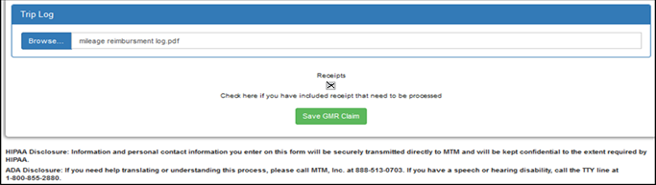Select “Save GMR Claim” when you are ready to submit your claim.
3. After submission, you will see a confirmation page with a claim number.
4. 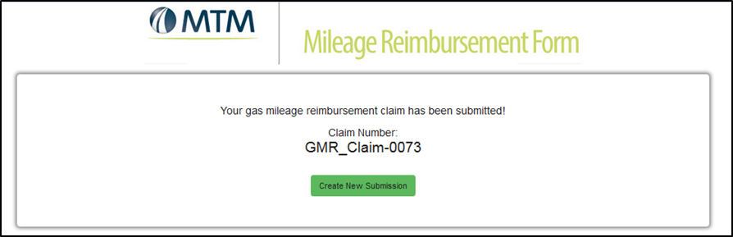To create a new claim for another member, select “Create New Submission.”